Oral Medicine & Intra-Oral Soft Tissue Referral Form
Email to: gwh.omfs@nhs.net Photographs must be attached with all soft tissue referrals

Patient details
Name Enter patient’s full name | Date of Birth Click or tap to enter a date.
Gender Male ☐ Female ☐ | NHS No (Mandatory) Enter NHS number  GWH No (if known) Enter GWH number
Address Patient address
Postcode Enter postcode
Home telephone Click to enter text. | Mobile telephone Click to enter text.
Referral Information: Routine ☐ URGENT ☐ 2WW ☐ (explain why in description of problem)
Medical History: (including medical conditions, medications, allergies/reactions, smoking and alcohol status
Click to enter text

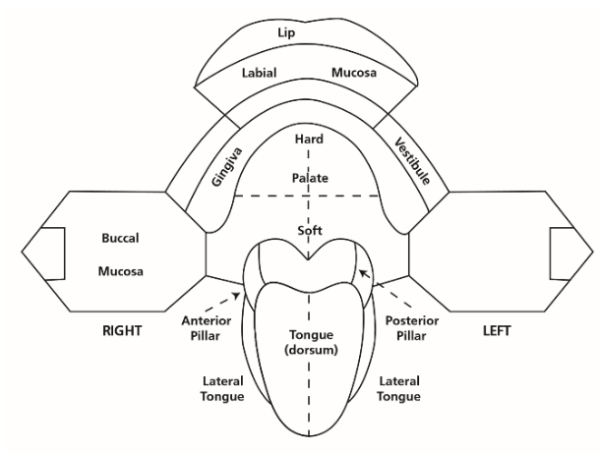
Reason for Referral:

Description of problem, provisional diagnosis, treatment provided and treatment/service requested

Please use anatomical terms for description where possible (see mouth map provided for terms)

Photographs must be attached to all soft tissue referrals
Description of problem

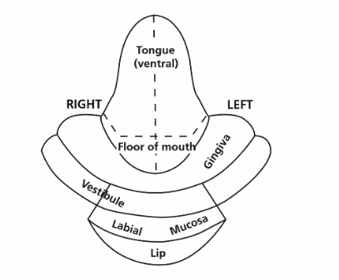

Confirmation of consent:
I confirm I have discussed with the patient the nature of the referral ☐
I confirm that I have assessed the treatment required is beyond my skill/experience ☐
I understand that incomplete or inappropriate referrals will be returned ☐

Name of referring dentist Click to enter text.  GDC number Click to enter text. | Date of referral Click to enter a date.
Address of referring dental practice Click to enter text.

