Oral Medicine & Intra-Oral Soft Tissue Referral Form

Email to: [gwh.omfs@nhs.net](mailto:gwh.omfs@nhs.net) Photographs must be attached with all soft tissue referrals

|  |  |
| --- | --- |
| **Patient details** | |
| **Name** Enter patient’s full name | **Date of Birth** Click or tap to enter a date. |
| **Gender** Male  Female | **NHS No** (Mandatory) Enter NHS number  **GWH No** (if known) Enter GWH number |
| **Address**  Patient address  **Postcode** Enter postcode | |
| **Home telephone** Click to enter text. | **Mobile telephone** Click to enter text. |
| **Referral Information**: Routine   **URGENT**  **2WW**  (explain why in description of problem) | |
| **Medical History:** (including medical conditions, medications, allergies/reactions, smoking and alcohol status  Click to enter text | |

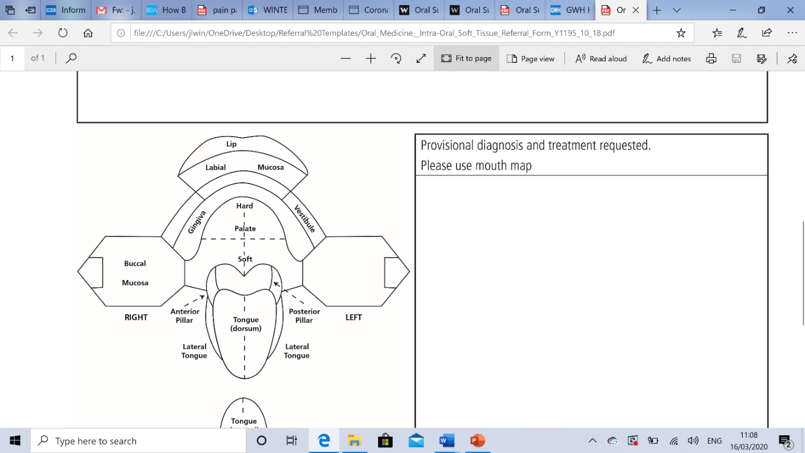

|  |
| --- |
| Reason for Referral:  Description of problem, provisional diagnosis, treatment provided and treatment/service requested  Please use anatomical terms for description where possible (see mouth map provided for terms)  Photographs must be attached to all soft tissue referrals |
| Description of problem |

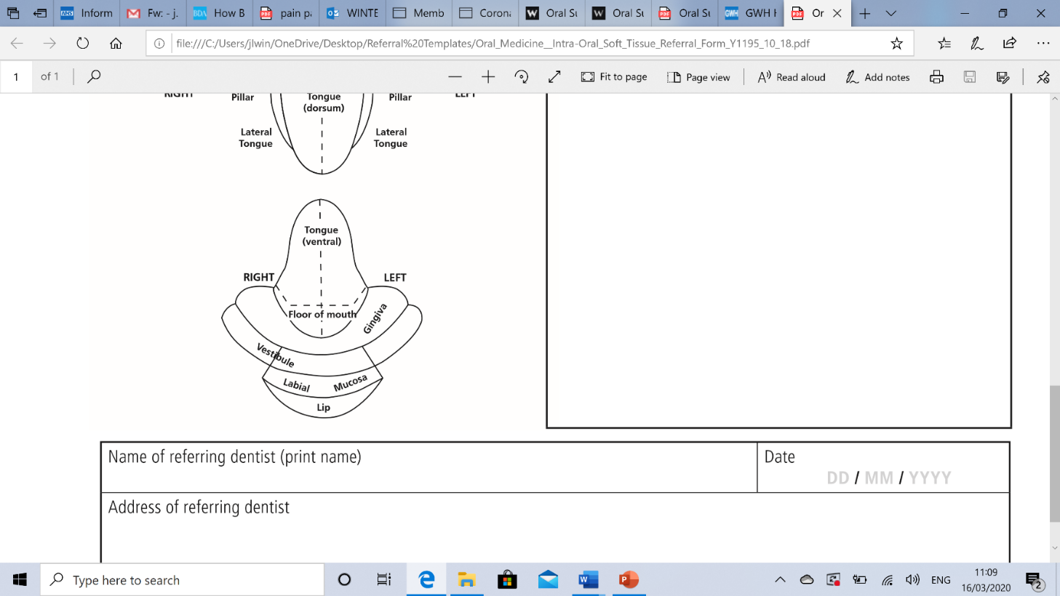

|  |  |
| --- | --- |
| **Confirmation of consent:**  I confirm I have discussed with the patient the nature of the referral  I confirm that I have assessed the treatment required is beyond my skill/experience  I understand that incomplete or inappropriate referrals will be returned | |
| **Name of referring dentist** Click to enter text.  **GDC number** Click to enter text. | **Date of referral** Click to enter a date. |
| **Address of referring dental practice** Click to enter text. | |