**Risk Management Strategy**

|  |  |  |  |  |  |  |  |
| --- | --- | --- | --- | --- | --- | --- | --- |
| **Document No** | Corp - 00003 | | | | | **Version No** | 3.0 |
| **Approved by** | Trust Board | | | | | **Date Approved** | 09/04/2020 |
| **Ratified by** | Trust Board | | | | | **Date Ratified** | 09/04/2020 |
| **Date implemented ( made live for use)** | | | | 21/04/2020 | | **Next Review Date** | 09/04/2023 |
| **Status** | | LIVE | | | | | |
| **Target Audience-** who does the document apply to and who should be using it. - The target audience has the responsibility to ensure their compliance with this document by:   * Ensuring any training required is attended and kept up to date. * Ensuring any competencies required are maintained. * Co-operating with the development and implementation of policies as part of their normal duties and responsibilities. | | | | | All employees directly employed by the Trust whether permanent, part-time or temporary (including fixed-term contract). It applies equally to all others working for the Trust, including private-sector, voluntary-sector, bank, agency, locum, and secondees. For simplicity, they are referred to as ‘employees’ throughout this policy | | |
| **Special Cases** | | None | | | | | |
| **Accountable Director** | | | | | Chief Executive | | |
| **Author/originator** – Any Comments on this document should be addressed to the author | | | | | Director of Governance and Assurance | | |
| **Division and Department** | | | | | Corporate. Corporate Governance | | |
| **Implementation Lead** | | | | | Director of Governance and Assurance | | |
| **If developed in partnership with another agency ratification details of the relevant agency** | | | | |  | | |
| **Regulatory Position** | | | NHS Resolution and NHS Improvement, the Independent Regulator of NHS Foundation Trusts (Ref 10).  National Audit Office Financial Governance and Audit Practice document (Ref 11) | | | | |
| **Review period**. This document will be fully reviewed every three years in accordance with the Trust’s agreed process for reviewing Trust -wide documents. Changes in practice, to statutory requirements, revised professional or clinical standards and/or local/national directives are to be made as and when the change is identified. | | | | | | | |

Contents

1 Introduction & Purpose 4

1.1 Introduction & Purpose 4

1.2 Glossary/Definitions 4

2 Main Document Requirements 5

2.1 Key Principles of this Strategy 5

2.2 Definition of Risk Management 5

2.3 Categorisation of Risks 6

2.4 Acceptable Risk 6

2.5 Objectives 6

2.5.1 Strategic Objectives 6

2.6 Risk Management Organisational Structure 7

2.6.1 Risk Management Organisational Chart 7

2.7 Accountability for Risk / Risk Escalation Framework 8

2.8 Trust Board 8

2.9 Audit, Risk and Assurance Committee 8

2.10 Board Committees 9

2.11 Executive Committee 9

2.12 Division Meetings 9

2.13 Departments and Teams 10

2.14 Individual Management 10

2.15 Risk Management Process 10

2.15.1 How all Risks are Assessed 10

2.15.2 How Risk is Managed 10

2.15.3 Review of Risk Scoring and Actions 10

2.15.4 Actions 11

2.16 How Risks are Escalated through the Organisation 11

2.17 Authority to Manage Risk 11

2.17.1 15+ ‘Extreme Risk’ (Red) 11

2.17.2 8-12 ‘High Risk’ (Amber) 11

2.17.3 4-6 ‘Moderate Risk’ (Yellow) 12

2.17.4 1-3 ‘Low Risk’ (Green) 12

2.18 Board Assurance Framework 12

2.18.1 Purpose of the Board Assurance Framework 12

2.18.2 Content of the Board Assurance Framework 12

2.18.3 Process for Compiling the Board Assurance Framework 12

2.18.4 Scrutiny and Challenge Including Frequency 12

2.19 Safeguard Risk Management Tool 13

2.19.1 Electronic Risk Register 13

2.19.2 Content 13

2.19.3 Source of the Risk 13

2.19.4 Acceptable Risk 13

2.19.5 Adding Risks to the Safeguard Risk Management Tool 13

2.20 Risk Awareness Training for Board Members 14

3 Monitoring Compliance and Effectiveness of Implementation 14

4 Duties and Responsibilities of Individuals and Groups 15

4.1 Chief Executive 15

4.2 Ward Managers, Matrons and Managers for Non Clinical Services 15

4.3 Document Author and Document Implementation Lead 16

4.4 All Employees 16

4.5 Board of Directors 16

4.6 Director of Governance and Assurance 16

4.7 Executive Directors 16

4.8 Associate Medical Directors 16

4.9 Divisional Directors 17

4.10 Risk, Legal and Governance Facilitator 17

4.11 Line Managers 17

5 Further Reading, Consultation and Glossary 18

5.1 References, Further Reading and Links to Other Policies 18

5.2 Consultation Process 19

6 Equality Impact Assessment 19

Appendix A - STAGE 1: Initial Screening For Equality Impact Assessment 20

Appendix B – Risk Assessment Matrix 22

Appendix C : Standard Operating Procedure (SOP) for Risk Register Entries for Risks 12+ or where the consequence score is 5. 24

Summary of Management of Risks

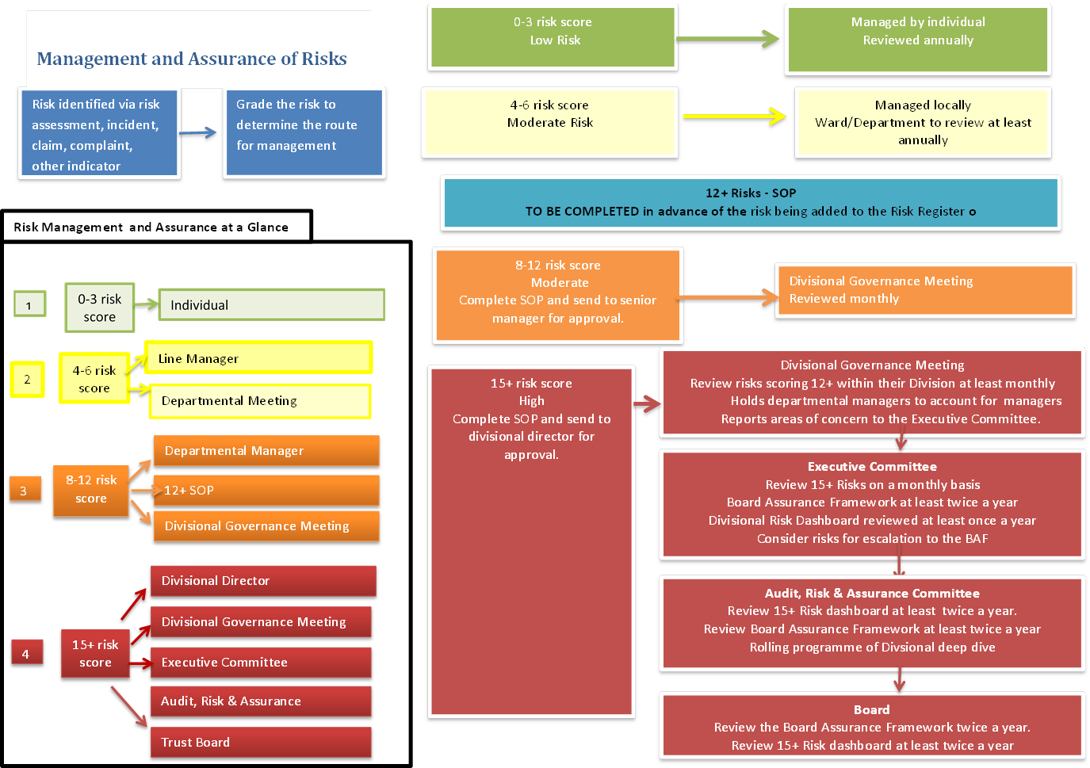

# 1 Introduction & Purpose

## 1.1 Introduction & Purpose

Great Western Hospitals NHS Foundation Trust (the Trust) is committed to implementing the principles of good governance, defined as the system by which the organisation is directed and controlled, at its most senior levels, to achieve its objectives and meet best practice standards in accountability, probity and openness. The Trust recognises that the principles of governance must be supported by an effective risk management system.

The purpose of the Risk Management Strategy is to provide a clearly defined and documented framework to ensure that risks to the achievement of the Trust’s objectives are identified and managed in a consistent manner, appropriate to the level of risk in order to reduce the risk.

This is the predominant risk management strategy in the Trust. The Maternity Services Risk Management Strategy (Ref 9) has been developed to supplement the Trust Risk Management Strategy; however this remains subservient to the Trust-wide Risk Management Strategy.

Failure to implement a strategy for managing risk could have a severe impact on patient health, the Trust’s reputation and the health and safety of employees and visitors; it would also be a breach of the Trusts statutory obligations. It could also have serious financial consequences. The Trust’s Risk Management Strategy is integral to delivering the Trust’s objectives and Annual Plan.

## Glossary/Definitions

The following terms and acronyms are used within the document:

|  |  |
| --- | --- |
| **15+ Risk Dashboard** | An extract of the Safeguard Risk Management Tool containing those risks which scored a 15 or above in accordance with the Trust How To Assess Risk Procedural Document (Ref. 8) |
| **ARAC** | Audit, Risk and Assurance Committee |
| **Board Members** | Executive and non-executive directors on the Trust Board |
| **CNST** | Clinical Negligence Scheme for Trusts |
| **Control** | A measure put in place in order to mitigate risk |
| **CoSHH** | Control of Substances Hazardous to Health Regulations 2002 |
| **CQC** | Care Quality Commission |
| **DoH** | Department of Health |
| **EIA** | Equality Impact Assessment |
| **H&S** | Health and Safety |
| **Hazard** | The potential for harm, misfortune, damage or loss. |
| **HSE** | Health and Safety Executive |
| **HSMR** | Hospital Standardised Mortality Ratio |
| **IP&C** | Infection Prevention and Control |
| **Local** | A subdivision of the organisation such as division or specialty |
| **LTPS** | Liabilities to Third Parties Scheme |
| **NHS** | National Health Service |
| **NHSR** | National Health Service Resolution |
| **NPSA** | National Patient Safety Agency |
| **PHSO** | Parliamentary and Health Service Ombudsman |
| **PQC** | Patient Quality Committee |
| **Residual risk** | The level of risk which remains when all practicable control measures have been implemented |
| **RIDDOR** | Reporting of Injuries, Diseases and Dangerous Occurrences Regulations 1995 |
| **Risk** | The likelihood of harm, misfortune, damage or loss due to realisation of a hazard. |
| **Rule 28** | A recommendation from the Coroner ` |
| **Safeguard Risk Management Tool** | Electronic repository for risks raised in the Trust, and a risk management tool |
| **Senior Managers** | For the purposes of the Risk Management Strategy, senior managers are defined as Associate Medical Directors and Divisional Directors |
| **SI** | Serious Incident |
| **SIRO** | Senior Information Risk Owner |
| **Specific Area** | A term used to describe specific areas in the Trust that, although not divisions, have their own division-style Risk Register, e.g. Mental Health |
| **Employees** | Used to refer to anyone working for the Trust, including NHS employees employed by the Trust, private-sector, voluntary-sector, agency, locum, contract, seconded and volunteers. |

# 2 Main Document Requirements

## 2.1 Key Principles of this Strategy

* All employees are responsible for identifying and managing risks;
* Accountability for managing risk will be determined by the risk score;
* Risks will be assessed in a consistent manner, by adopting the National Patient Safety Agency (NPSA) risk assessment matrix in the How To Assess Risk Policy and Procedure (Ref 6);
* Training will be provided to employees to support the identification and management of risks;
* The Trust will operate a Board Assurance Framework and a Risk Register that will enable systematic oversight and scrutiny of risk;
* The Trust will share learning on risk management success and controls throughout the organisation.

## 2.2 Definition of Risk Management

Risk management is a systematic and cyclical process, in which potential risks are identified, assessed, managed, monitored and reviewed. It is applicable at all levels – Board, divisional, department, team and individual.

Risk management is a proactive approach which:

* Identifies the various activities of the organisation;
* Identifies the hazards that exist within those activities and the risks associated with those hazards;
* Assesses those risks for likelihood and potential severity;
* Eliminates the risks that can be eliminated;
* Reduces the effect of those risks that cannot be eliminated;
* Acknowledges those risks that can be accepted;
* Seeks to engage with employees to understand risks and explain tolerated risks; and
* Regularly monitors and reviews all risks.

## Categorisation of Risks

Risks come in many forms. The Trust has adopted the Care Quality Commission (CQC) domains to categorise its risks and included finance as an additional category.

|  |
| --- |
| **CQC Domains** |
| Safety |
| Effectiveness |
| Caring |
| Responsiveness |
| Well Led |
| Finance |

Risk Group is a mandatory field on the Safeguard Risk Management Tool (see Section 2.19 of this document) to ensure that all risks added to the system are categorised.

## Acceptable Risk

The Trust recognises that it is not possible to eliminate all risks, either because of the high costs of elimination in comparison with the potential severity of the risk, other priorities or other external factors.

When all reasonable control measures have been put in place some residual risk might remain and this level of risk can be accepted if the risk:

1. is minor in nature, with minimal potential for financial loss or damage to structure, persons, equipment or property; or
2. will occur rarely and might cause serious harm, damage or loss but which would take disproportionate resources to eliminate or reduce.

Where risks are deemed ‘accepted’ with no further action to be taken, they should still be reviewed in case circumstances have changed. The frequency of the review will depend on the level of risk. The minimum review frequency for accepted risks is set out below.

|  |  |  |
| --- | --- | --- |
| **Risk score** | **Level of risk** | **Review frequency** |
| 1-3 | Low risk | Yearly |
| 4-6 | Moderate risk | Yearly |
| 8-12 | High risk | Quarterly |
| 15+ | Extreme risk | Monthly† |

**†All risks that score 15 or above can only be deemed ‘accepted’ by Trust Board. All risks which score 15 or above must be reviewed at least monthly, irrespective of whether they are deemed ‘accepted’.**

100% of all risks that have been accepted on the Risk Register must have evidence attached to the risk in the form of documentation that records the decision to accept the risk. Each division’s compliance with evidencing acceptance is reported to Executive Committee on a quarterly basis.

## Objectives

## Strategic Objectives

The Trust set out its strategic objectives in the Great Western Hospitals NHS Foundation Trust 5 Year Plan for 2019-24 (Ref 16).

They are:

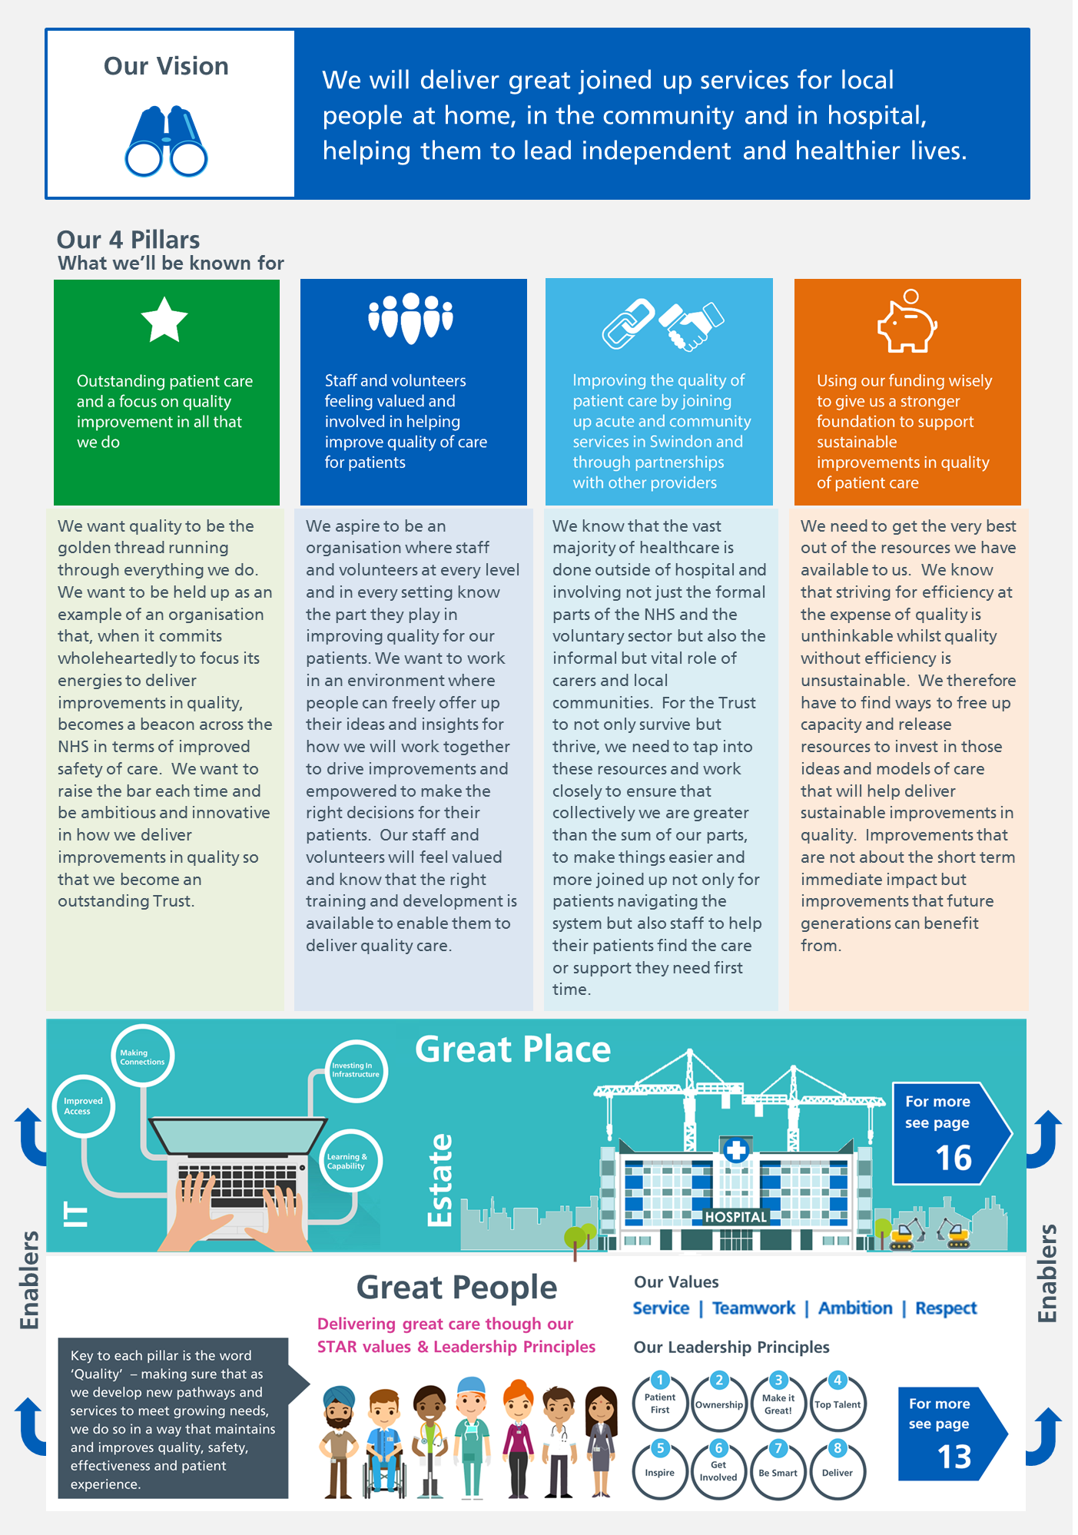

## Risk Management Organisational Structure

**Note - Please refer to terms of reference (Ref 7) for Committees in conjunction with this strategy for more information on the role of these committees. These are available from the Director of Governance & Assurance.**

## Risk Management Organisational Chart

|  |
| --- |
| Trust Board  Overarching responsibility for risk.  Ratify the Risk Management Strategy.  Review the Board Assurance Framework twice a year.  Review 15+ Risk dashboard at least twice a year. |
| Audit, Risk and Assurance Committee (ARAC) (process assurance)  Assures Trust Board of the effectiveness of the risk management processes.  Reviews 15+ Risk dashboard at least twice a year.  Reviews Board Assurance Framework at least twice a year. |
| Board Committees  On a quarterly basis, receives assurances in relation to those BAF risks which have been delegated to the committee by the Board. |
| Executive Committee (operational responsibility)  Reviews the Board Assurance Framework twice a year.  Oversight that risks are being managed.  Scrutinises the 15+ Risks monthly  Reviews each divisional risk dashboard once a year. |
| Divisional meetings (operational responsibility)  Reviews divisional risk dashboards monthly.  Direct action to mitigate high-scoring risks (12+) within Division |
| Departmental meetings (operational responsibility)  Reviews departmental risks.  Direct action to mitigate risks within the Department. |

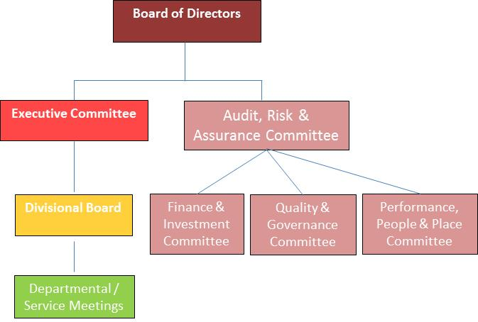

## Accountability for Risk / Risk Escalation Framework

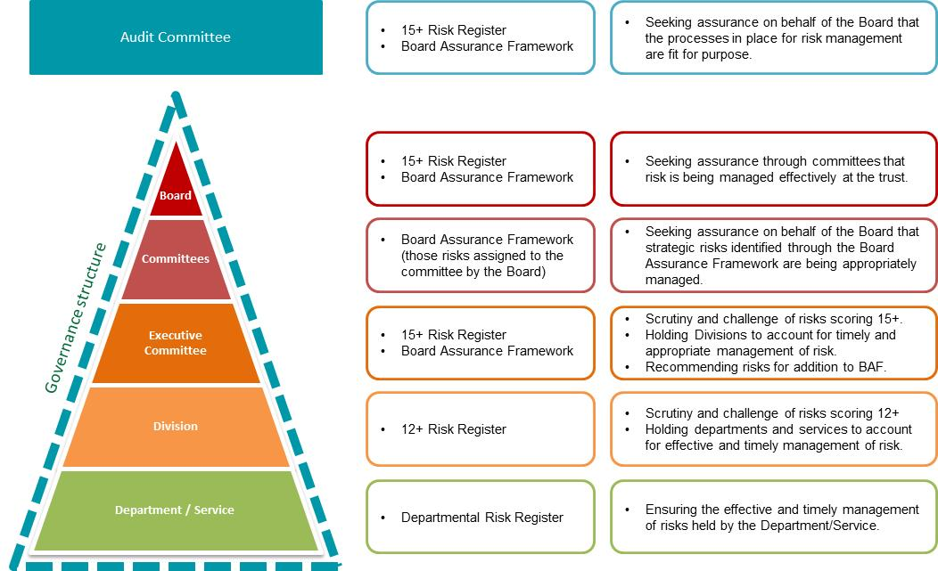

## Trust Board

The Trust Board is responsible for risk management throughout the Trust. It delegates some responsibility to the Executive Committee and the Audit, Risk and Assurance Committee and receives assurance from those committees on the effectiveness of the risk management strategy. To discharge its responsibilities it will:

* Ratify the Trust’s Risk Management Strategy every three years;
* Review the 15+ Risks at least twice a year;
* Review the Board Assurance Framework twice a year;
* Delegate responsibility for taking assurance on the risk management processes to the Audit, Risk and Assurance Committee.

## Audit, Risk and Assurance Committee

The role of the Audit, Risk and Assurance Committee is to oversee the implementation of the Risk Management Strategy and to take assurances that the processes supporting the Risk Management Strategy are effective in mitigating risk. It does not have operational responsibility for individual risks, but will take assurances from the Executive Committee that risks are being managed. Its specific responsibilities are:

* To review the 15+ Risks at least twice a year;
* To review the Board Assurance Framework at least twice a year.

The Audit, Risk and Assurance Committee will also receive assurances from the Board Committees to supplement the overall assessment of risk and the effectiveness of the risk management process within the Trust.

Where the Audit, Risk and Assurance Committee identifies significant gaps in the Trust’s risk management strategy or processes for managing risk, the Chair of the Committee will make a verbal report to Trust Board and if deemed necessary to the Council of Governors.

## Board Committees

There are three Board Committees with responsibility for seeking assurance relating to work within their remit.

The Quality & Governance Committee is particularly concerned with quality and safety matters and ensuring risk mitigation in these areas, whereas the Finance and Investment Committee is engaged in regular reviews of risk outcomes of financial performance and both short and longer term financial planning with actions to mitigate financial risks being identified. The Performance, People and Place Committee is concerned with operational performance, workforce, estates, IT and business continuity.

Each of these committees has delegated oversight of those relevant strategic risks from the Board Assurance Framework which have been assigned to them by the Board. The committees will undertake the following roles in relation to the Board Assurance Framework;

* Seek assurance on a quarterly basis that the strategic risks under the Strategic Objective(s) aligned to the remit of the Committee are effectively managed and mitigated.
* Consider the scoring of those strategic risks based upon the assurance received.
* Report any gaps in assurances or deterioration on strategic risks scores to the Board by exception.

## Executive Committee

The Executive Committee has operational responsibility to ensure risks are being managed. It has specific responsibility to:

* Scrutinise and challenge the 15+ Risks on a monthly basis;
* Consider risks for escalation to the Board Assurance Framework and where identified recommend these for inclusion to the Board;
* Scrutinise and challenge the Board Assurance Framework at least twice a year;
* Scrutinise and challenge each Divisions Risks once a year;
* Hold Associate Medical Directors and Divisional Directors to account using the Risk Report on how risks are managed within their Division, directing action where appropriate.

Where a 15+ risk is considered accepted by the Executive Committee, this should be reported to the next Trust Board by the Chair of Executive Committee, for formal agreement that the 15+ risk can be accepted with no further action to be taken.

## Division Meetings

For the purposes of the Risk Management Strategy, the Divisions are defined as follows:

* Corporate;
* Clinical Support and Specialist Services Division
* Planned Care;
* Unscheduled Care;
* Women’s and Children’s and Sexual Health
* Community Services
* Primary Care

Division meetings will:

* Scrutinise risks scoring 12+ within their Division at least monthly (the review, together with any action taken, must be minuted);
* Holds departmental managers to account for managing their risks;
* Reports areas of concern to the Executive Committee.

## Departments and Teams

Departments and Teams will review their risks to ensure their management and will report any areas of concern to the Divisional meeting.

## Individual Management

Individuals are responsible for management of risks where they are the risk owner/manager. Actions must be identified to mitigate risk and recorded on the Risk Register. In addition, progress against these actions must be recorded on the Risk Register and actions closed once they have been completed. Risks must be reviewed in a timely manner as specified in accordance with the frequency of review.

## Risk Management Process

## How all Risks are Assessed

All risks are assessed in accordance with the 5x5 NPSA risk management matrix (Appendix B - Risk Assessment Matrix). For more information, refer to the Trust’s How To Assess Risk Policy and Procedure (Ref 6).

The Trust will ensure that risk assessments are conducted in a consistent manner by:

* Adopting the NPSA Risk Assessment Matrix for the assessment of all risks (Appendix B- Risk Assessment Matrix);
* Providing training to employees on risk assessment at induction;
* How To Assess Risk Policy and Procedure (Ref. 6) available to all employees through the intranet;
* Employing an electronic risk management system with mandatory fields (Section 2.19.2);
* Employing a standardised paper-based risk assessment form which is part of the How To Assess Risk Policy and Procedure (Ref 6);
* Ensuring challenge and scrutiny of risks at all levels – committees, divisions, teams (Section 2.18.4).

## How Risk is Managed

All employees are responsible for identifying and managing risk. Where a risk can be immediately mitigated this must be done, e.g. remove trailing cables.

If a risk cannot be immediately mitigated, employees must conduct a risk assessment in accordance with the How To Assess Risk Policy and Procedure available on the T Drive (Ref 6).

## Review of Risk Scoring and Actions

Once the risk has been assessed and scored, if the risk score is 8 or more the member of staff must notify their line Manager who will add the risk to the Risk Register unless it contains confidential employee or patient information when action outlined below in 2.16 must be followed.

## Actions

All risk must include actions where the risk is to be mitigated or eliminated. Actions to be taken to mitigate/eliminate a risk will be documented.

## How Risks are Escalated through the Organisation

Risk escalation will be determined by risk score.

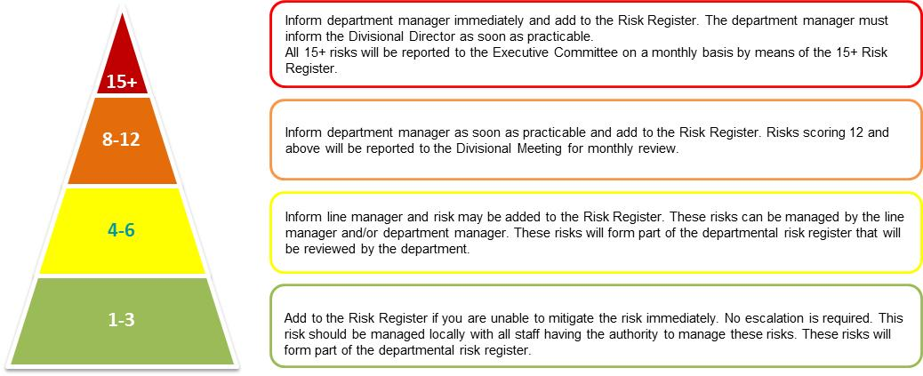

Where risk assessments concern specific patients or employees and contain confidential information they must not be added to the Risk Register in order to avoid breaching patient or staff confidentiality. Such risk assessments must be stored in the patient’s health record, or employee personnel folder.

**Where there is an immediate risk to the health and wellbeing of patients, employees or visitors, this must be escalated immediately. If outside of normal working hours, the risk must be reported to the on-call manager for assistance.**

## Authority to Manage Risk

The authority to manage risk is determined by the risk category. Risk categories are based on the NPSA risk management matrix (Appendix B).

## 15+ ‘Extreme Risk’ (Red)

Individuals must inform the department manager immediately and add to the Risk Register. The department manager must inform the Associate Medical Director or Divisional Director as soon as practicable. All 15+ risks will be reported to the Executive Committee on a monthly basis by means of the 15+ Risk Report.

### 8-12 ‘High Risk’ (Amber)

Individuals must inform department manager as soon as practicable and add to the Risk Register.

All open risks that have been added to the Risk Register from a Division, will populate that Division’s risk dashboard that will be reviewed by the Executive Committee at least once a year. It is expected that the Divisions’ 12+ risks be discussed monthly, at a Division management or governance meeting.

**Standard Operating Procedure for Risks Scoring 12 + or containing a consequence score of 5**

Where a risk assessment or risk review identifies a risk score of 12+ or a consequence score of 5 a standard operating procedure (SOP) (Appendix C) must be applied. A risk matrix & template will be completed. This will be presented to the Divisional Management Team for review in advance of the risk being added to the Risk Register. The purpose behind the SOP is to check the risk scoring and actions in advance of any escalation, thus ensuring that the high level risks are appropriate.

### 4-6 ‘Moderate Risk’ (Yellow)

The individual must inform line manager and the risk may be added to the Risk Register. These risks can be managed by the line manager and/or department manager.

### 1-3 ‘Low Risk’ (Green)

The individual may add these to the Risk Register if they are unable to mitigate the risk immediately. No escalation is required. This risk must be managed locally with all employees having the authority to manage these risks.

## Board Assurance Framework

The Board Assurance Framework (BAF) is a document which identifies the sources of assurances that inform the strategic risk scores.

## Purpose of the Board Assurance Framework

To ensure that risks to the Trust achieving its strategic objectives are identified promptly; that control measures are put in place to mitigate those risks; to ensure that assurances are taken throughout the year; and to ensure that those control measures are effective in mitigating the risk.

## Content of the Board Assurance Framework

The Board Assurance Framework will reflect the Trust strategic objectives. Risks will be identified against those objectives. New risks to the strategic objectives of the Trust identified through the year will be added to the Board Assurance Framework by the Executive Committee and the Board.

Each quarter the Board Assurance Framework will be reviewed by the Director of Governance & Assurance who will add details of:

* Assurances received since the last review;
* Gaps in control (where identified);
* Gaps in assurances.

## Process for Compiling the Board Assurance Framework

Each financial year, after publication of the Trust Annual / Operational Plan, the Director of Governance & Assurance will revise the Board Assurance Framework based on the risks identified in the Annual Plan for the year ahead. Where possible, the Director of Governance & Assurance will identify the controls measures, sources of assurance and any gaps in the control framework, before meeting with each of the Executive Directors to review the Board Assurance Framework.

## Scrutiny and Challenge Including Frequency

The relevant sections of the Board Assurance Framework are presented to the Board Committees quarterly to enable the Committee to review the assurances and controls in place to mitigate the strategic risks. The Committee will use the BAF to inform their Committee Forward Plans and their discussion and challenge of agenda items and will draw to the attention of the Board any issues or concerns through their Chair report.

The Executive Committee will review the BAF at least twice a year to scrutinise and challenge the assurances and controls and instruct any actions as necessary.

At least twice a year, the Audit, Risk and Assurance Committee will take assurances from the Executive Committee and Board Committee that the Board Assurance Framework accurately reflects the risk profile of the Trust and that risks are being appropriately managed. Trust Board will then review the Assurance Framework twice a year.

## Safeguard Risk Management Tool

## Electronic Risk Register

From the 1 April 2012, the Trust has used the Safeguard system for its Risk Register. The purpose of the Risk Register is to enable oversight and scrutiny of risks and to support the reduction of risk by identifying necessary mitigating actions. The additional purpose of the Risk Register is a centralised system to allow oversight of all risks, identify risk themes and monitor risk management across the Trust.

## Content

The Trust prescribes the following minimum content of the Risk Register: -

* Reference number;
* Risk description;
* Source of the risk;
* Nature of risk;
* Current status (accepted, action required, closed)
* Original risk score, current risk score, residual risk score;
* Action to mitigate risks, with due dates, progress reports and action leads;
* Operational and Executive leads.

## Source of the Risk

Risks are identified through the following process and are added to the Risk Register

* Incident reports;
* Risk assessments;
* Local risk registers;
* External recommendations.
* National Risk Register

## Acceptable Risk

See Section 2.4.

## Adding Risks to the Safeguard Risk Management Tool

Only employees that have received training on the Safeguard Risk Management System are provided with access. Where an employee member who is not trained identifies a risk that scores 8 or above, he or she must report the risk to their department manager so that the risk can be added. If in doubt, the department manager can contact the Risk, Legal and Governance Facilitator on 01793 605426 to find out who is trained within their Division.

## Risk Awareness Training for Board Members

A one-off training session for Board Members covering the principles of, and the Trust’s approach to, risk management is required. As a minimum the session will cover:

* Principles of risk management;
* Board Assurance Framework;
* Risk assessment;
* Using the risk Management System

# Monitoring Compliance and Effectiveness of Implementation

The arrangements for monitoring compliance are outlined in the table below: -

|  |  |  |  |  |  |
| --- | --- | --- | --- | --- | --- |
| **Measurable policy objectives** | **Monitoring or audit method** | **Monitoring responsibility (individual, group or committee)** | **Frequency of monitoring** | **Reporting arrangements (committee or group the monitoring results is presented to)** | **What action will be taken if gaps are identified** |
| Adequacy of Terms of Reference of Committees with overarching responsibility for risk (Executive & Audit Risk and Assurance Committees) | Review of terms of reference – consideration by respective committees | Trust Board | At least once per year | Trust Board | ToR will be amended by the Director of Governance & Assurance. |
| Compliance with Terms of Reference of Committees with overarching responsibility for risk | Review of compliance – report to Committee  Reporting arrangements through the Committees to the Board | Director of Governance & Assurance | At least once per year as part of annual reporting | Trust Board | ToR will be amended by the Director of Governance & Assurance. |
| Development and maintenance of a Board Assurance Framework | Audit conducted by Trust internal auditors | Director of Governance & Assurance | As per internal audit plan | Audit, Risk and Assurance Committee | Director of Governance & Assurance will be responsible for ensuring actions from the audit report are completed and providing assurance to ARAC. |
| 15+ Risks review and scrutiny | Scrutinised and challenged at committee | Executive Committee  Audit, Risk and Assurance Committee | Monthly  At least 3 times a year | Trust Board | The Director of Governance & Assurance will be responsible for acting on recommendations and reporting back to the auditors. |
| Duties of key individuals | Risks are identified, recorded on the division risk registers, action plans in place and registers reviewed | Executive Committee workshops | At least once per year | Audit, Risk and Assurance Committee | Actions documented |
| Division risk review and scrutiny | Scrutinised and challenged by meetings / Committee | Division meetings  Executive Committee | Monthly  At least once per year | Executive Committee | Actions minuted, followed-up at future Executive Committee meetings. |
| 95% compliance with risk management training for Board Members | Training records  Training material  Attendance sheet | Director of Governance & Assurance | Ad hoc. Following group training session or following commencement of employment. | Audit, Risk and Assurance Committee | Slides and signature sheet sent out for completion. Followed up with line manager if non-compliance. |

# 4 Duties and Responsibilities of Individuals and Groups

## Chief Executive

The Chief Executive is ultimately responsible for the implementation of this strategy.

## Ward Managers, Matrons and Managers for Non Clinical Services

All Ward Managers, Matrons and Managers for Non Clinical Services must ensure that employees within their area are aware of this document; able to implement the document and that any superseded documents are destroyed.

## Document Author and Document Implementation Lead

The document Author and the document Implementation Lead are responsible for identifying the changes to this strategy in response to changes in practice, changes to statutory requirements, revised professional or clinical standards and local/national directives, and, if changes are required, resubmitting an amended strategy for approval and republication.

## All Employees

All employees are required to comply with all relevant legislation and regulation, attend training where appropriate and maintain their own professional competencies, ensuring they are familiar with, and comply with, Trust policies, procedures and other documents.

All employees have a responsibility to ensure any risks that they identify are flagged to their line manager in the first instance. Employees must be aware of risk management procedures and be willing to report incidents and risk management issues.

## Board of Directors

The Board is responsible for ensuring that the Trust has effective systems for identifying and managing all risk; clinical, financial and organisational. Responsibility for monitoring the effectiveness of these systems is delegated to the Audit, Risk and Assurance Committee. The Executive Committee is delegated authority to oversee the management of the Risk Management system and together with the Board Committees provide assurance to inform the Audit, Risk and Assurance Committee that processes are being maintained and risks are managed.

The Board has established a risk management structure to help deliver its responsibility for implementing risk management systems within the Trust which is explained below. Trust Board will review the 15+ Risks and the Board Assurance Framework at least twice a year. Only Trust Board may determine that a risk where the residual score is 15 or above following implementation of all mitigating actions and controls is ‘accepted’.

## Director of Governance and Assurance

The Director of Governance & Assurance has overall accountability to the Board for ensuring that an effective risk management system is in place within the Trust and for meeting all statutory requirements. The Director of Governance & Assurance is responsible for implementation of risk management and is the Executive Lead on maintaining the Board Assurance Framework. The Chief Executive is the Accounting Officer.

## Executive Directors

Executive Directors are directly accountable to the Board for effective risk management within their areas of responsibility. They are required to ensure that risks are identified promptly and managed effectively in accordance with this Strategy and any associated documents, policies and procedures. Executive Directors are responsible for ensuring that Associate Medical Directors are aware of their responsibilities under this Strategy and for compliance.

## Associate Medical Directors

Associated Medical Directors are responsible for the management of both strategic and operational risk within their Divisions. This includes the implementation of risk management procedures and for escalating risks that cannot be managed at a local level. They are responsible for the Division and specific-area risks and accountable to the Executive Committee on risk management. They are responsible for:

* Promoting a risk management culture within the Trust by actively encouraging the identification of risks;
* Identifying a suitable local forum (usually monthly division meetings) for the discussion of risk management issues;
* Consideration and discussion of risk management issues at that forum;
* Development and implementation of work plans to ensure risks are identified and treated;
* Ensuring Division risks are maintained and reviewed at least four times a year to ensure timely and systematic risk management and communication of risk;
* Ensuring escalation of risks from divisions for inclusion in the 15+ Risk Dashboard/attention of the Board.
* Confirming to the Executive Committee on an annual basis that risk is being managed effectively when their respective risk registers are presented.

## Divisional Directors

Divisional Directors are responsible for supporting the Associate Medical Directors in managing risk within their divisions/specific areas. They are responsible for:

* Ensuring that appropriate and effective risk management processes are in place within designated areas and scope of responsibility and that all employee are made aware of the risks within their work environment and of their personal responsibilities;
* Implementing and monitoring any identified risk management control measures within their designated area and scope of responsibility ensuring that they are appropriate and adequate;
* Ensuring that risks are captured onto division/specific-area risk ; and
* Ensuring that a local group (usually the monthly division/specific-area meetings) review the Division/specific-area risks.

## Risk, Legal and Governance Facilitator

The Risk, Legal and Governance Facilitator is responsible for:

* Supporting Divisions in compiling division risk dashboards.
* Providing support and training on the Risk System.
* Producing Divisional Risk Dashboards using data from the Safeguard system on a monthly basis to support the review of risk at Divisional Governance Meetings.
* Supporting the Director of Governance & Assurance with compiling a 15+ Risk Dashboard and report; and
* Providing administrative support and training on the Safeguard Risk register.
* Provide support to department in the monthly production of the template which enables them to produce and report on their area risks.

## Line Managers

All employees with managerial responsibility must understand and implement the Trust’s Risk Management Strategy and underlying policies. They are responsible for the following:

* Ensuring they have adequate knowledge of relevant legislation, seeking advice from appropriate experts where necessary and ensuring that compliance with legislation is maintained.
* Ensuring that this strategy is implemented in their areas and that employees are made aware of their individual responsibilities.
* Ensuring that employees have access to the necessary information and training to enable them to work safely.
* Ensuring that necessary information is made available to bank and agency staff, contractors, members of the public and visitors.
* Ensuring appropriate resources are available and procedures are in place to implement this strategy.
* Promoting greater risk management and health and safety awareness amongst all employees.
* Ensuring that risks are identified, evaluated, recorded and reviewed.
* Ensuring that employees comply with relevant policies including health and safety, fire, occupational health, CoSHH, and first aid.

This list is not exhaustive.

# Further Reading, Consultation and Glossary

## 5.1 References, Further Reading and Links to Other Policies

The following is a list of other policies, procedural documents or guidance documents (internal or external) which employees should refer to for further details:

| **Ref. No.** | **Document Title** | **Document Location** |
| --- | --- | --- |
| 1 | Claims Management Policy | T:\Trust-wide Documents |
| 2 | Complaints Policy | T:\Trust-wide Documents |
| 3 | Health and Safety Policy | T:\Trust-wide Documents |
| 4 | Incident Management Policy | T:\Trust-wide Documents |
| 5 | Information Governance Policy | T:\Trust-wide Documents |
| 6 | How To Assess Risk Policy and Procedure | T:\Trust-wide Documents |
| 7 | Terms of Reference for committees of the Trust Board | Director of Governance & Assurance |
| 8 | Freedom to Speak up Policy: Raising Concerns Policy | T:\Trust-wide Documents |
| 9 | Maternity Service Risk Management Strategy | T:\Trust-wide Documents |
| 10 | NHS Improvement – Independent Regulator of Foundation Trusts | https://improvement.nhs.uk |
| 11 | National Audit Office Financial Governance and Audit Practice | [www.nao](http://www.nao).org.uk |
| 12 | Board Assurance Framework | Director of Governance & Assurance |
| 13 | Safeguard Adults at Risk Policy | T:\Trust-wide Documents |
| 14 | Mandatory Training Policy | T:\Trust-wide Documents |
| 15 | Inquests Guidance | T:\Trust-wide Documents |
| 16 | The Trust Strategy 2019-2024 | GWH Intranet |
| 17 | Risk Management Tool : Guides and Documents | GWH Intranet |

## 

## Consultation Process

The following is a list of consultees in formulating this document:

| **Job Title / Department** |
| --- |
| Audit, Risk and Assurance Committee |
| Executive Committee |
| Executive Directors |
| Health & Safety Advisor |
| Legal & Inquest Manager |

# 6 Equality Impact Assessment

An Equality Impact Assessment (EIA) has been completed for this document and can be found at Appendix A.

# Appendix A - STAGE 1: Initial Screening For Equality Impact Assessment

|  |  |  |  |
| --- | --- | --- | --- |
| At this stage, the following questions need to be considered: | | | |
| 1 | What is the name of the policy, strategy or project?  Risk Management Strategy | | |
| 2. | Briefly describe the aim of the policy, strategy, and project. What needs or duty is it designed to meet?  The aim of the Risk Management Strategy is to have a positive impact on our ability to deliver high quality care by providing a framework for identify and managing risks before they materialise. | | |
| 3. | Is there any evidence or reason to believe that the policy, strategy or project could have an adverse or negative impact on any of the nine protected characteristics (as per Appendix A)? |  | **No** |
| 4. | Is there evidence or other reason to believe that anyone with one or more of the nine protected characteristics have different needs and experiences that this policy is likely to assist i.e. there might be a *relative* adverse effect on other groups? |  | **No** |
| 5. | Has prior consultation taken place with organisations or groups of persons with one or more of the nine protected characteristics of which has indicated a pre-existing problem which this policy, strategy, service redesign or project is likely to address? |  | **No** |

|  |  |
| --- | --- |
| Signed by the manager undertaking the assessment | Carole Nicholl |
| Date completed | 5 February 2020 |
| Job Title | Director of Governance & Assurance |

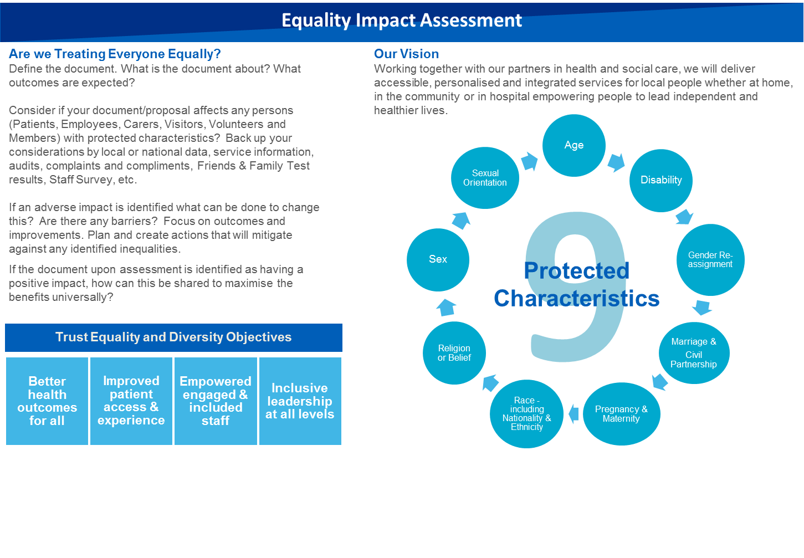

# 

# Appendix B – Risk Assessment Matrix

See also the separate How to Assess Risk Procedural Document (Ref. 8)

The overall risk rating reflects both the likelihood that harm or loss will occur and the severity of its outcome: **(i.e. risk = likelihood x consequence).**

|  |  |  |  |  |  |  |  |  |  |
| --- | --- | --- | --- | --- | --- | --- | --- | --- | --- |
|  |  | | (1) | (2) | (3) | | (4) | (5) |  |
| Consequence | Catastrophic (5) | | 5 | 10 | 15 | | 20 | 25 | (5) |
| Major (4) | | 4 | 8 | 12 | | 16 | 20 | (4) |
| Moderate (3) | | 3 | 6 | 9 | | 12 | 15 | (3) |
| Minor (2) | | 2 | 4 | 6 | | 8 | 10 | (2) |
| Negligible (1) | | 1 | 2 | 3 | | 4 | 5 | (1) |
|  | | Rare  (1) | Unlikely (2) | Possible (3) | | Likely  (4) | Almost certain (5) |  |
|  |  | | Likelihood | | | | | |  |
|  | *based on an NPSA template | | | |  | |  |  |  |
| **THE OVERALL RESIDUAL RISK RATING** | | | | | | | | | | | | |
| **Low Risk (1-3)**  Quick easy measures implemented immediately, and further action planned for when resources permit | | | **Moderate Risk (4-6)**  Actions implemented as soon as possible, but not later than a year | | | | **High Risk (8-12)**  Actions implemented as soon as possible and no later than six months | | | | | **Extreme Risk (15+)**  Requires urgent action. Trust Board is made aware and implements corrective action |

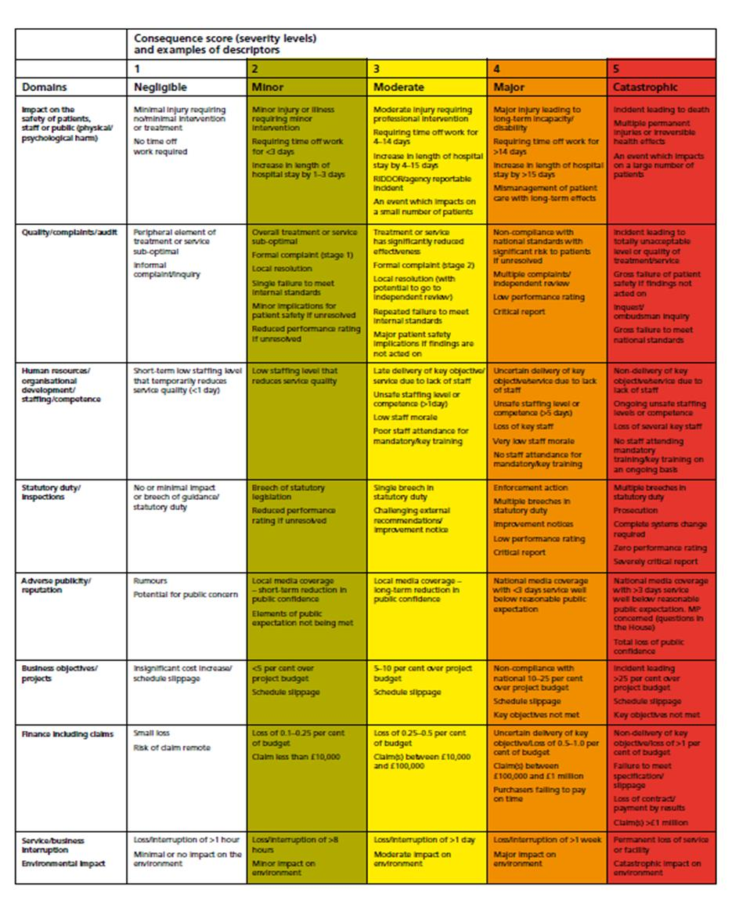

# Appendix C : Standard Operating Procedure (SOP) for Risk Register Entries for Risks 12+ or where the consequence score is 5.

**Purpose**

To ensure that the risk register is appropriately identifying, controlling, mitigating and managing its risks and to ensure that the management team is fully aware of all risks affecting all service provision with the Trust Risk Escalation Framework

**Procedure for Risks 12+ and/or that contain a consequence score of 5.**

When a new risk is identified, or a known risk needs changing or the risk is to be closed, it must be brought to the attention of the appropriate senior manager responsible for managing that risk within their area of responsibility by completing the Template, appendix 1.

The senior manager must consider what mitigating and control measures might be possible and whether the ‘risk’ constitutes something over and above normal routine business. The risk matrix with the controls and actions will be discussed and approved accordingly.

The senior manager must then arrange to provide a briefing on the risk(s) to the Division’s Senior Management Team on a weekly basis.

In the event that it is necessary to update the risk register or add a risk on an **exceptional/urgent** **basis** the template must be sent to the Division’s Senior Management Team immediately for approval for entry onto the risk register by the senior manager.

Due regard should be given to the Trust’s Board approved Risk Tolerance Statement when considering adding/amending or closing a risk.

|  |  |  |  |  |  |  |  |  |  |  |  |
| --- | --- | --- | --- | --- | --- | --- | --- | --- | --- | --- | --- |
| **Template for Risk Register Entries for Risks 12+ and/or consequence score of 5** | | | | | | | | | | | |
| **Department** |  | | **Senior Manager** | | |  | | | | | |
|  | | | **Head of Service** | | |  | | | | | |
| **Risk Number** | **Description of Risk (200 Characters)** | | | | | | **Likelihood Score** | | **Consequence Score** | **Proposed Risk Score** | |
|  |  | | | | | |  | |  |  | |
| **Controls** | | | | | | | | | | | |
| **Control** | | **Gap in Control** | | **Confidence Score (1-3)** | **Assurance** | | | **Gaps in Assurance** | | | **Confidence (Hi, Med, Low)** |
|  | |  | |  |  | | |  | | |  |
|  | |  | |  |  | | |  | | |  |
|  | |  | |  |  | | |  | | |  |
|  | |  | |  |  | | |  | | |  |
|  | |  | |  |  | | |  | | |  |

|  |  |  |  |  |  |  |  |  |  |  |  |  |  |  |  |  |  |  |  |  |  |  |  |  |  |  |
| --- | --- | --- | --- | --- | --- | --- | --- | --- | --- | --- | --- | --- | --- | --- | --- | --- | --- | --- | --- | --- | --- | --- | --- | --- | --- | --- |
|  | | **Actions** | | | | | | | | | | | | | | | | | | | | | | | | |
| **1** |  | | | | | | | | | | | | | | | | **4** |  | |  | | | | | |
| **2** |  | | | | | | | | | | | | | | | | **5** |  | |  | | | | | |
| **3** |  | | | | | | | | | | | | | | | | **6** |  | |  | | | | | |
|  |  | | | (1) | | (2) | | (3) | | (4) | | (5) | |  | |  | | | **Approval** | | | | | |  | | | |
| Consequence | **Catastrophic** | | | **5** | | **10** | | **15** | | **20** | | **25** | | (5) | |  | | | Approved Likelihood Score | | Approved Consequence Score | Approved Risk Score | Date Approved | | Who/Meeting Approved | | | |
| **Major** | | | **4** | | **8** | | **12** | | **16** | | **20** | | (4) | |  | | |  | |  |  |  | |  | | | |
| **Moderate** | | | **3** | | **6** | | **9** | | **12** | | **15** | | (3) | |  | | |
| **Minor** | | | **2** | | **4** | | **6** | | **8** | | **10** | | (2) | |  | | | | | | | | |  | | | |
| **Negligible** | | | **1** | | **2** | | **3** | | **4** | | **5** | | (1) | |  | | | |
|  | | **Rare** | | **Unlikely** | | **Possible** | | **Likely** | | **Almost Certain** | |  | |  | | | | | | | | |  | | | |
|  | Likelihood | | | | | | | | | | | | |  | |  | | | | | | | | |  | | | |